

**S. B. JAIN INSTITUTE OF TECHNOLOGY, MANAGEMENT & RESEARCH, NAGPUR.**

**Practical No. 5**

**Aim:** Understand and apply basic tags of CSS and Create a Tribute Page using Internal CSS on VS code/Sublime Text Editor.

**Name of Student: Priti deshpande**

**Roll No.: AD22028**

**Semester/Year: 2ND/1ST**

**Academic Session:**

**Date of Performance:**

**Date of Submission:**

**AIM:** Understand and apply basic tags of CSS and Create a Tribute Page using Internal CSS on VS code/Sublime Text Editor.

**OBJECTIVE/EXPECTED LEARNING OUTCOME:**

The objectives and expected learning outcome of this practical are:

• To apply the knowledge of basic and advanced CSS tags.

• To know about Internal Stylesheets of CSS

• Able to design page using HTML/CSS.

**HARDWARE AND SOFTWARE REQUIREMENT**:

**Hardware Requirement**

**•** 1.6 GHz or faster processor

• .RAM: 1GB

• Hard Disk Drive: > 80 GB

**Software Requirement**

**•** Operating System – Windows 2007,2010.

• Editor – Visual Studio Code /SublimeText.

**THEORY:**

**CSS: Cascading Style Sheet**

* CSS is used to control the style of a web document in a simple and easy way
* CSS is the language we use to style an HTML document.
* The World Wide Web Consortium (W3C) created CSS.

**Syntax:**

**selector {property: value}**

**There are three ways of inserting a style sheet**

1**.** External CSS

2. Internal CSS

3. Inline CSS

**Types of Selectors:**

**1. The CSS element Selector**

**• The element selector selects HTML elements based on the element name.**

**p {**

**text-align: center;**

**color: red;**

**}**

**<p>Paragraph</p>**

**2. The CSS id Selector**

* To select an element with a specific id, write a hash (#) character, followed by the id of the element.

**<style>**

**#ClassName {**

**text-align: center;**

**color: red;**

**}**

**</style>**

**<body>**

**<ul id=”classname”>**

**<li>Some Text</li>**

**<li>Some Text</li>**

**</ul>**

**</body>**

**3. The CSS class Selector**

To select elements with a specific class, write a period (.) character,followed by the class name

**<style>**

**.center {**

**text-align: center;**

**color: red;**

**}**

**</style>**

**<body>**

**<div class=”center”> Content of HTML</div>**

**</body**

**CODE: <!doctype html>**

**<html> <body>**

**<form>**

**<h1> Registration Form </h1>**

**<label> Name: </label><input type="text"><br><br> <label> Email ID: </label><input type="email"><br><br>**

**<label> Phone Number: </label><input type="number"><br><br> <label> Gender: </label><input type="radio"name="gender">Male**

**<input type="radio"name="gender">Female<br><br> <label> Hobbies: </label><input type="checkbox" name="hobbies">**

**Singing**

**<input type="checkbox" name="hobbies">Dancing <input type="checkbox" name="hobbies">Cooking<br><BR> <label> Courses: </label><select>**

**<option name="B.tech">B.tech</option> <option name="M.tech">M.tech</option>**

**<option name="MCA">MCA</option>**

**<option name="BCA">BCA</option>**

**<option name="MBA">MBA</option><br><br> <label> Password: </label><input type="password">**

**</form>**

**</body>**

**</html>**

**OUTPUT/SCREENSHOTS:**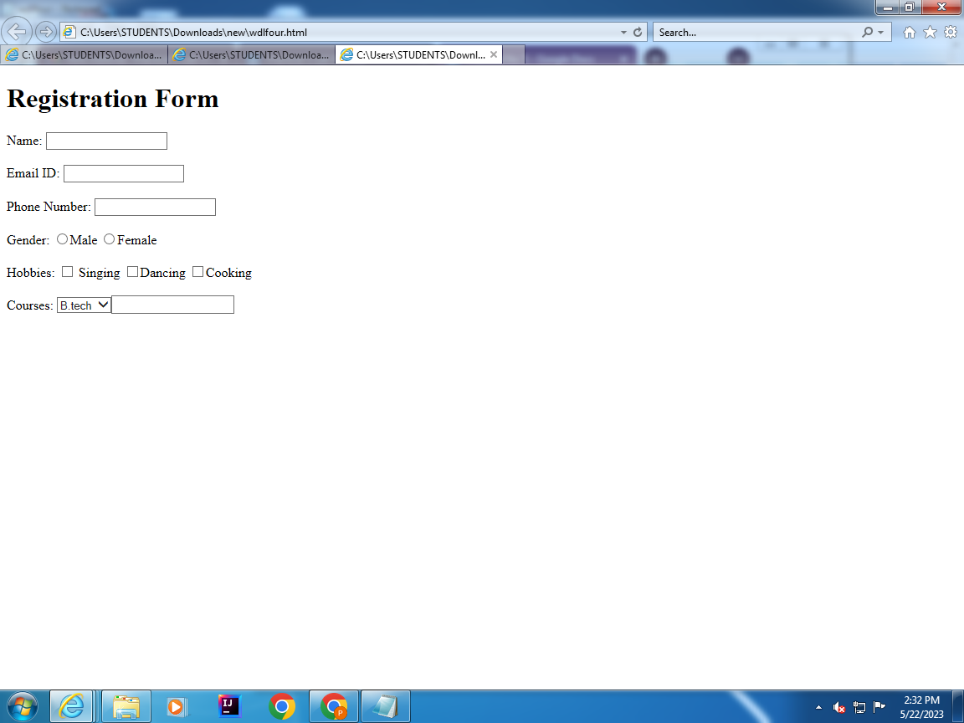

**CONCLUSION:**

**DISCUSSION QUESTIONS:**

1. What is the use of CSS?

2. Which are the limitation of CSS?

3. What are the different types of selectors in CSS?

4. What are the advantages of using CSS?

5. Explain the syntax of CSS.

**REFERENCE:**

*•* [*https://www.w3schools.com/css/*](https://www.w3schools.com/css/)

*•* [*https://www.codecademy.com/learn/learn-css*](https://www.codecademy.com/learn/learn-css)

*•* [*https://www.tutorialspoint.com/css/index.htm*](https://www.tutorialspoint.com/css/index.htm)

*•* [*https://www.interviewbit.com/css-interview-questions/*](https://www.interviewbit.com/css-interview-questions/)